**IMPERIALISM IN CHINA**

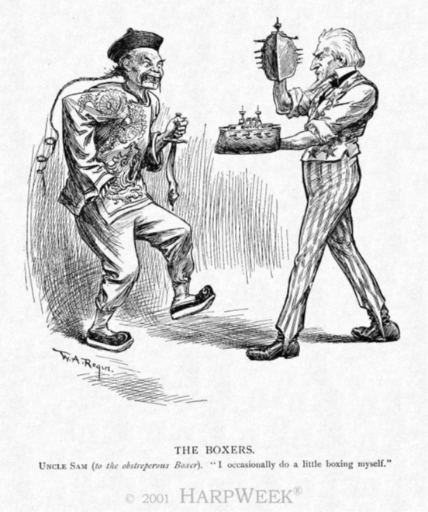

**William Allen Rogers, political cartoon about the relationship between the United States and the Boxers, “The Boxers,” *Harpers Weekly*, June 9, 1900.**

1. **What perspective (USA or China?) is expressed in this cartoon?  How do you know?**  I believe that the perspective of this cartoon is that of the United States of America. This is because the Asian is portrayed very stereotypically, and the sources say so.
2. **How does this cartoon represent the relationships between Asian and Western nations during the Age of Imperialism?  Explain**. This cartoon shows that both Asia and the Western were very hostile towards each other and that their relationship is very militant. This is because it looks like both men are fighting each other.
3. **Identify and explain TWO symbols within this political cartoon.** One of the symbols are the navy ships since America was going to use the navy ships to claim territory in China. Furthermore, I believe the knife was a symbol to show fear.

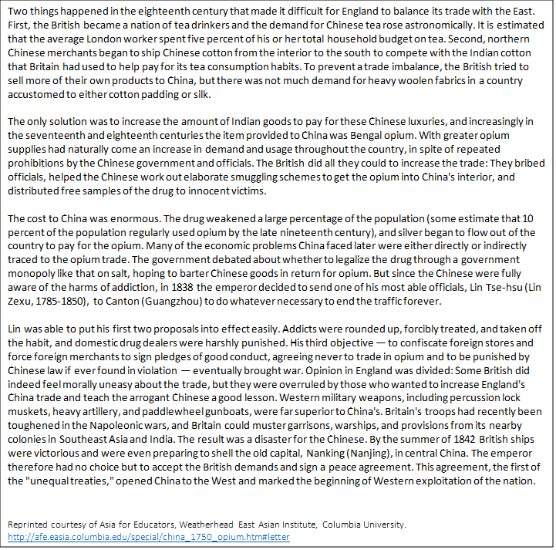

**Source A:**

**Using Source A, write 2-3 sentences describing how the Opium Wars created foreign influences in China and the reactions of the Chinese**. The Opium Wars created a large number of Opium addicts and had hurt the Chinese economy. The Opium Wars led to unfair treaties and the Chinese were mistreated. The drugs would weaken the bodies of the Chinese and addiction made them want to spend money on more opium. The Chinese was aware of the addicts and wanted to stop the traffic of opium trade.



**Source B:**

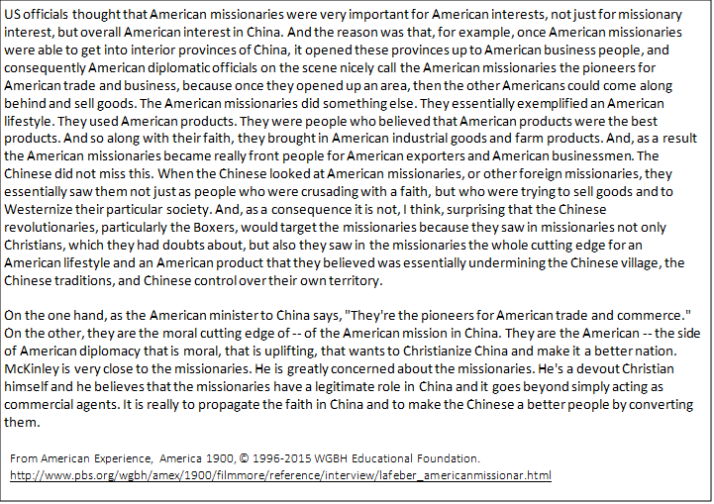

Source C:

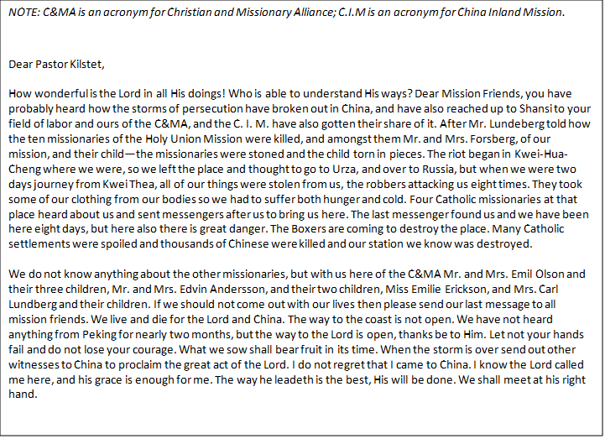

**Using Sources B & C, write a paragraph explaining the goals of Christian missionaries in China and describing the Boxers’ perspective on these missions.  Be sure to provide evidence (with a citation) from the sources to support your claim**!  There were two primary goals of Christian missionaries in China. One of those goals is to spread and bring the Christian faith to China. The missionaries thought that Christianity would let China advance into a more powerful global nation. Moreover, another goal of the missionaries is to westernize China. The missionaries did not have any malicious intentions and just wanted to expand their religion onto others. The missionaries wanted to introduce the western culture to China because they had viewed it as part of Christianity. The missionaries just wanted the Chinese to be more happy and tried their best to do so. In addition, the Boxer’s perspective on the missions were interesting because they saw the missionaries as hostile. They thought the missionaries were not even Christian at all, or only slightly Christian. Moreover, the Boxers thought that the missionaries were using western tools to negatively impact China. The Boxers would attack the missionaries due to this reason. The Boxers were very suspicious of the missionaries and did not want them to have any part in their country.